# CS 255 System Design Document Template

Mohamed Aziz Zaghdoudi

2/24/2024

## UML Diagrams

### UML Use Case DiagramUploaded image

### UML Activity Diagrams

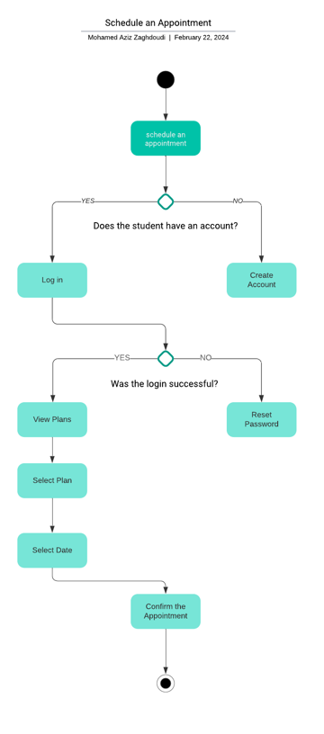

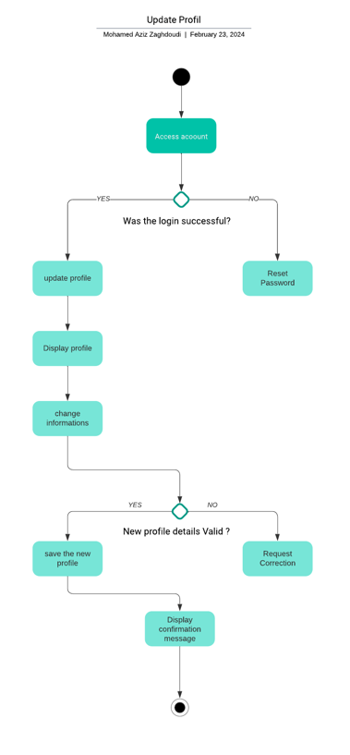

### UML Sequence Diagram

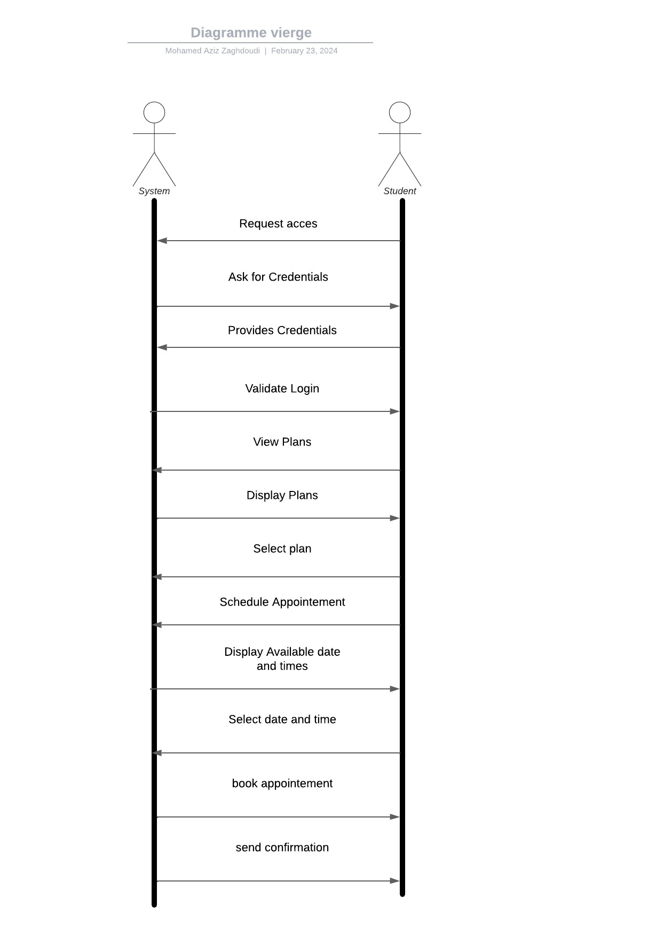

### UML Class Diagram

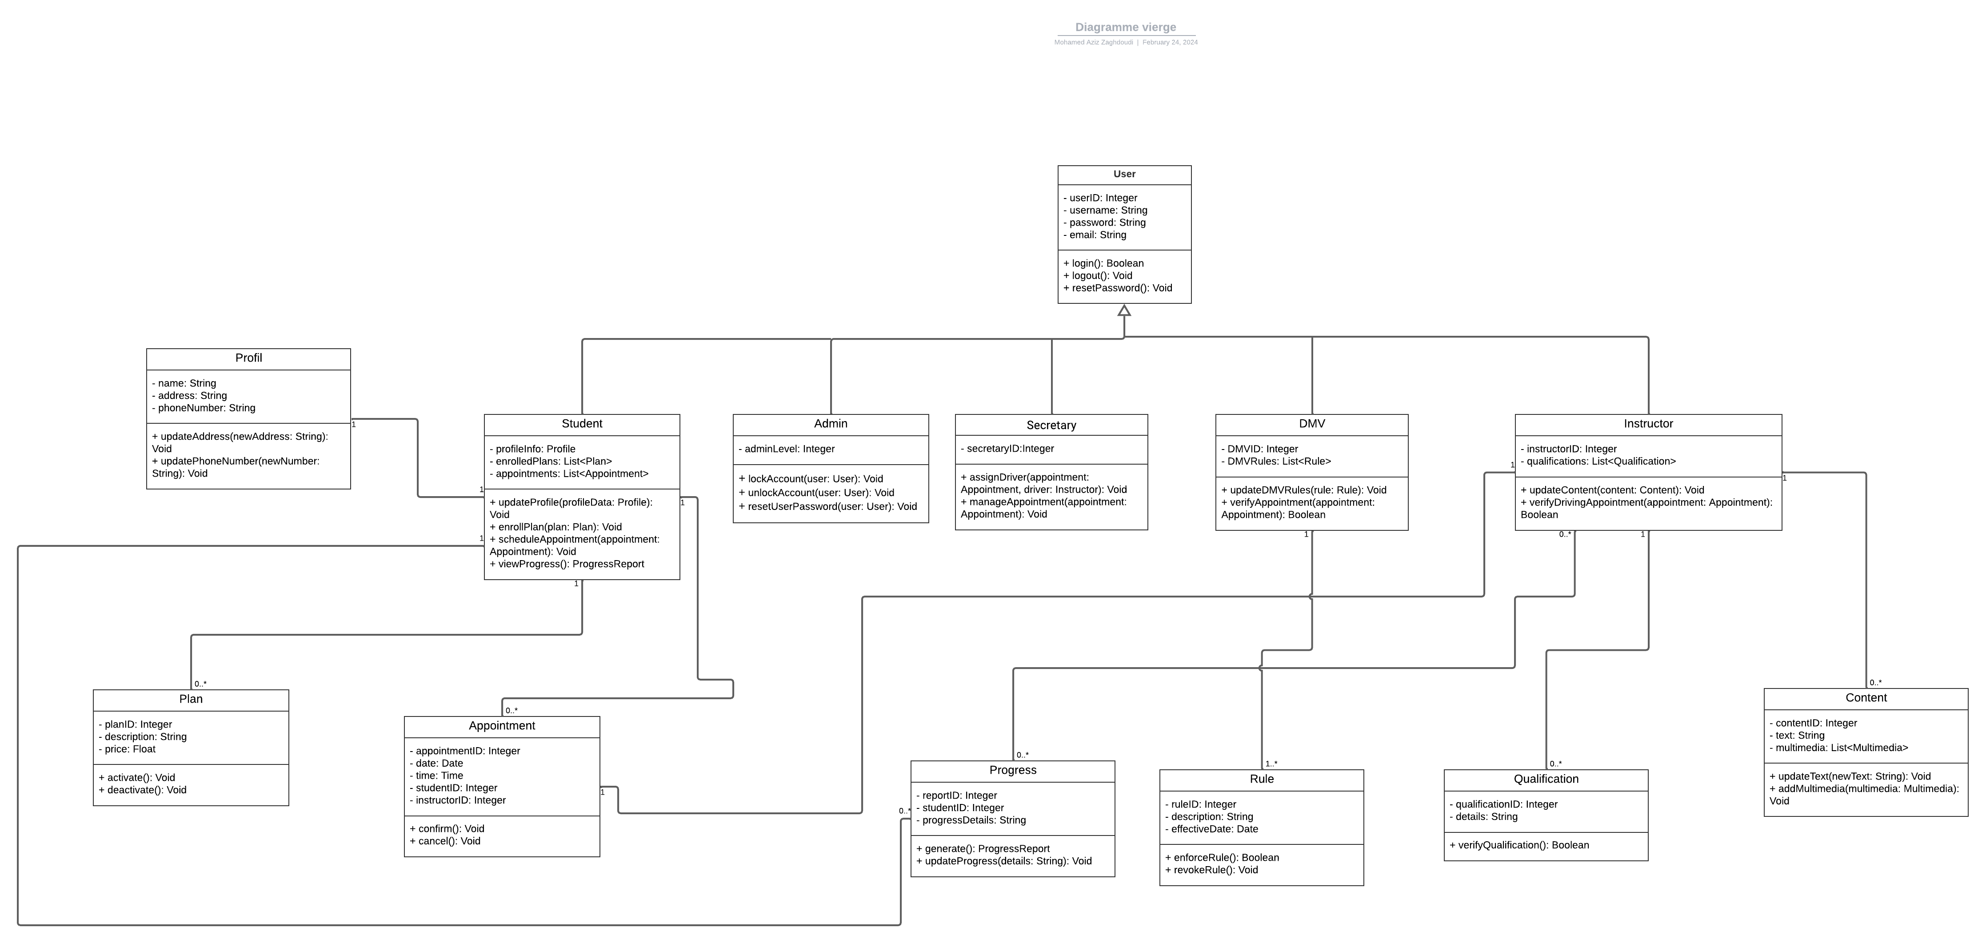

## Technical Requirements

The system will require a server infrastructure capable of hosting a web application, which suggests the need for both application and database servers. These servers should have adequate processing power, memory, and storage to handle concurrent user sessions and data processing with high availability and backup capabilities. A cloud-based solution such as AWS or Azure could offer scalability and reliability for these needs.

On the software front, a robust backend platform such as Java Spring Boot or .NET Core is recommended to handle the logic and workflows depicted in the activity diagrams. For the frontend, a modern JavaScript framework like React or Angular would provide a responsive user experience. The system should also implement a relational database management system like PostgreSQL or MySQL to manage user data, appointments, and other persistent data effectively.

Security is paramount, so the system must include authentication and authorization mechanisms, likely using OAuth or JWT for secure login processes. SSL/TLS encryption will be necessary for data in transit, and regular security updates and patches will be part of the maintenance requirements.

For development and maintenance, tools like Git for version control, Jira for project management, and Jenkins or a similar CI/CD platform for automating the build and deployment processes will be essential. Automated testing frameworks such as Selenium for end-to-end testing and JUnit for unit testing will ensure that the components work as intended, as defined by the sequence diagram.

In terms of hardware for end-users, since the system will be web-based, users will require devices with internet connectivity and browsers. No specific hardware requirements are needed beyond a standard web-compatible device such as a smartphone, tablet, or computer.

Lastly, to support the communication needs as highlighted by the use cases, an email server or integration with a third-party email service will be necessary for features like sending password reset links and appointment confirmations.

This infrastructure and toolset will provide a solid foundation for the technical needs of the DriverPass System, ensuring it can operate efficiently, securely, and be flexible enough to accommodate future enhancements.